Pls contact us :35007117@ qq.com
----------------------------------------------------------
Digital Temperature Module
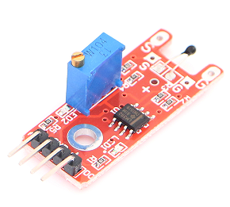
Digital Temperature module can connect UNO R3 PIN13, make Temperature test.
Pin 13’s LED，use Digital Temperature module connect Pin 3. When Digital Temperature module test there is Temperature , led can be bright.

Code：
int Led=13;//定义LED 接口
int buttonpin=3; //定义数字温度传感器接口
int val;//定义数字变量val
void setup()
{
pinMode(Led,OUTPUT);//定义LED 为输出接口
pinMode(buttonpin,INPUT);//定义数字温度传感器为输出接口
}
void loop()
{
val=digitalRead(buttonpin);//将数字接口3的值读取赋给val
if(val==HIGH)//当数字温度传感器检测有信号时，LED 闪烁
{
digitalWrite(Led,HIGH);
}
else
{
digitalWrite(Led,LOW);
}
}

